**The collapse of a keystone forage species: Rebuttal to Frank et al. 2016**

## Authors:

Buren, A.D.1§, Murphy, H.M. 1*§, Adamack, A.T.1, Davoren, G. K.2, Koen-Alonso, M.1, Montevecchi W. A.3, Mowbray, F. K.1, Pepin, P.1, Regular, P.1, Robert, D.4, Stenson, G.1, Varkey, D.1Rose G5?

## Affiliations:

1. Northwest Atlantic Fisheries Centre, Fisheries and Oceans Canada, St. John's, NL, Canada
2. Department of Biological Sciences, University of Manitoba, Winnipeg, MB, Canada
3. Cognitive and Behavioural Ecology Progamme, Departments of Biology and Psychology, Memorial University of Newfoundland, St. John’s, NL, Canada
4. Institut des sciences de la mer, Université du Québec à Rimouski, Rimouski, QC, Canada
5. CFER/ UBC ?

*corresponding author : Tel: +1 709 772 4925; Fax: + 1 709 772 4138; e-mail: Hannah.Murphy@dfo-mpo.gc.ca

§ A.B and H.M. contributed equally to this paper and others have contributed equally. Authors have been listed in alphabetical order for each contribution level.

## Abstract

Research conducted by the Canadian Department of Fisheries and Oceans found that the Newfoundland capelin stock suffered an order of magnitude decline in the early 1990s. Frank et al. (2016) disputed this conclusion and postulated that the capelin stock did not suffer a collapse but rather (1) capelin changed its migratory patterns while the timing of the acoustic survey has remained constant leading to a spatio-temporal mismatch between the survey and the stock, or (2) the capelin stock has become less migratory and are remaining in inshore waters, and therefore undetected by the offshore surveys. We tested these hypotheses using multiple independent datasets, which included both fishery-dependent (inshore commercial catch) and fishery-independent (spring acoustic and fall bottom trawl surveys, oceanography cruises, three capelin larval indices, aerial surveys, predator diet and behaviour) data, and diverse statistical methods. The hypothesis of a non-collapse of the capelin stock was rejected by our analyses. While inshore commercial catch rate, aerial surveys and the Trinity Bay larval index provide equivocal support for the non-collapse hypothesis, the usefulness of these indices post-1991 have been called into question in both earlier Canadian government reports and in our analyses. The weight of evidence approach led us to conclude that the NAFO Div. 2J3KL capelin stock suffered a population collapse in 1991 with minimal recovery in the subsequent 25 years.

## Introduction

Small shoaling species that characteristically have rapid growth, short life expectancies, and population responses tightly linked to environmental control, known as forage fish, play crucial roles in many ecosystems, acting as conduits of energy between lower trophic levels and large vertebrate predators. These characteristics lead these species to exhibit boom and bust population dynamics, i.e. their abundances change rapidly and substantially and undergo phases of extremely high and extremely low abundances (Soutar & Issacs 1969, Schwartzlose et al. 1999, Chavez et al. 2003, Alheit et al. 2009, Pikitch et al. 2012). Forage fish species can experience prolonged periods of ‘bust’ dynamics. For example, the Norwegian spring-spawning herring (*Clupea harengus*) stock collapsed in the late 1960s and remained at very low levels until the late 1980s (Toresen & Østvedt 2000, Skagseth et al. 2015); and sardine (*Sardinops sagax*) and anchovy (*Engraulis* spp.) have decade-scale regimes of high and low abundances where populations thrived for 20 to 30 years and then disappeared for similar periods (Schwartzlose et al. 1999, Chavez et al. 2003). Capelin (*Mallotus villosus*) is the focal forage species in ecosystems of the northern Atlantic Ocean (Templeman 1948, Jangaard 1974, Vilhjálmsson 1994, Carscadden et al. 2001). The three most important capelin populations in the North Atlantic are in the Barents Sea, off the coast of Iceland, and on the Newfoundland and Labrador (Canada) continental shelf. The Barents Sea capelin stock experienced three collapses over the past 4 decades: the mid- to late-1980s, the mid-1990s, and the mid-2000s. The size of the stock fluctuated between 3 - 7 million tonnes during the boom phase and around 200 thousand tonnes during the bust phases. There is general agreement that ecosystem changes were the driving forces behind these dynamics (Gjøsæter et al. 2009). The Icelandic capelin stock underwent similar dynamics, with three bust phases over the past 4 decades: the early 1980s, the early 1990s, and most of the 2000s. The size of the stock was around 1.5 - 2 million tonnes during the boom phase and between 100-500 thousand tonnes during the bust phases (ICES 2017). The first two cases were due to a combination of poor recruitment and the stock being easily available to the fishing fleet, while the last case was likely associated with a climate-related shift in distribution (Pálsson et al. 2012, Carscadden et al. 2013).

Fisheries and Oceans Canada is responsible for the assessment of the Newfoundland and Labrador (NL) capelin stock; it has concluded that there was an order of magnitude decline in the stock in the early 1990s, and that capelin abundance declined to less than 1% of historic levels in 2010 (DFO 1994, Miller 1994, 1997, DFO 2008, 2010, 2013, 2015). The size of the stock fluctuated between 2 - 6 million tonnes prior to 1991, and between 25-900 thousand tonnes during the ensuing period (DFO 2015). This decline was concomitant with drastic changes in the ecosystem during the late 1980s and early 1990s (Hutchings & Myers 1994, Gomes et al. 1995, Lilly et al. 2000, Rice 2002, Koen-Alonso et al. 2010, Hammill et al. 2011, Pedersen et al. 2017), and coincided with major changes in the biology and ecology of capelin (Carscadden & Nakashima 1997, Carscadden et al. 2001, Nakashima & Wheeler 2002, DFO 2010). The collapse was identified as an important signal contributing to a regime shift that occurred in the early 1990s (Buren et al. 2014a, Pedersen et al. 2017). Several aspects of the stock’s dynamics, such as recruitment, growth, and mortality of pre-spawners, have been linked to bottom-up processes (Frank & Leggett 1981, Leggett et al. 1984, Dalley et al. 2002, Buren et al. 2014a, Obradovich et al. 2014, Murphy et al. 2018) with little empirical evidence of top-down processes (Carscadden et al. 2001) driving capelin population dynamics in NL.

Frank et al. (2016) argued that the capelin stock off NL did not collapse. The debate over the collapse or non-collapse of capelin in the NL region is not new and stems from the unexplained discordance between the inshore and offshore indices in the 1990s, when inshore indices suggested little change in capelin biomass since the 1980s while the offshore acoustic survey found a dramatic decrease in capelin biomass (Nakashima 1996, Carscadden & Nakashima 1997, Carscadden et al. 2001, DFO 2001b). This discordance resulted in the exclusion of the offshore acoustic survey as an input into the capelin multiplicative year-class model; however, this model still had large statistical uncertainties (Evans & Nakashima 2002), suggesting that the inshore indices alone did not explain capelin year class variability. This model is no longer in use as the number of inshore indices collected has been reduced over time (DFO 2000). Since 1999, the index of capelin biomass from the offshore acoustic survey has been considered the best method of obtaining an index of capelin biomass for the Newfoundland and Labrador continental shelf (O'Driscoll et al. 2002, Mowbray 2014), which is in accordance with the methods used for capelin fisheries in Iceland and the Barents Sea (e.g., Gjøsæter et al. 2009, ICES 2017).

Frank et al. (2016) postulated that the reported collapse was not real and proposed two hypotheses to interpret why the offshore spring acoustic surveys have failed to detect large capelin aggregations since 1991: 1) capelin changed their migratory patterns while the timing of the acoustic survey has remained constant leading to a spatio-temporal mismatch between the survey and the stock, and 2) the capelin stock has become less migratory and are remaining in inshore waters, and therefore undetected by the offshore surveys. Support for the non-collapse of capelin was based on changes in biology of capelin post-1991 (e.g., distribution and demography), re-analysis of the offshore research surveys (multi-species bottom trawl and acoustic), and the response of various components of the ecosystem (e.g., zooplankton, northern cod, seabirds, seals) to the large-scale changes that occurred during the early 1990s (Frank et al. 2016). The objective of this paper is to assess the empirical support for the hypotheses of stock collapse (DFO 2015) vs non-collapse (Frank et al. 2016) using all available data.

## Integrated overview of NL ecosystem

### Offshore capelin distribution: acoustic surveys

In the NL region, the capelin stock has been surveyed by both Canada and the former USSR using acoustic methods since the 1970s (see Anon 1995, Mowbray 2014 for more details) (Fig. 1). From 1982 to 1992, Canada conducted two acoustic surveys annually for capelin that were initially designed to survey two separate stocks (Div. 2J3K and Div. 3L) (Campbell & Winters 1973). However, meristic (Misra & Carscadden 1984) and tagging studies (Nakashima 1992) supported the existence of only a single stock unit in NAFO Div. 2J3KL in 1992. Spring acoustic surveys in May in NAFO Div. 3L targeted an important nursery area for juvenile capelin. These surveys provided abundance estimates of age-2 capelin that would be recruited into the fishery in the following year. Fall acoustic surveys in October in NAFO Div. 2J3K targeted the maturing portion of the stock to provide revised estimates of the size and number of maturing fish being recruited to the fishery in the following year. The dramatic decline of capelin in the spring acoustic estimate in 1991, which was not reflected in the inshore indices (Carscadden & Nakashima 1997), instigated the dropping of the spring survey in favour of an expanded fall survey (NAFO Div. 2J3KL) in 1993-94. However, the expanded fall acoustic survey did not find the ‘missing’ capelin biomass from the spring survey and failed to reconcile discrepancies between the inshore and offshore indices. The fall survey was subsequently cancelled and a spring acoustic survey in NAFO Div. 3L has been conducted annually since 1996 (except in 1997, 1998, 2006 and 2016).

The capelin stock in NAFO Div. 2J3K was also acoustically surveyed by the former USSR in November from 1972-1992. The USSR acoustic survey covered a more restricted geographic area compared to the Canadian acoustic survey as it did not go as far into the inshore area (Anon 1995). The USSR fall acoustic surveys were conducted after the Canadian surveys and consistently estimated higher capelin abundances, which may have been due to timing, as capelin cease feeding in November and aggregate into large overwintering (?) shoals (Anon 1995). In 1990, the Canadian fall acoustic survey estimated a very low capelin biomass and the USSR acoustic survey estimated the smallest biomass since 1984 (Anon 1995). Both the USSR and Canadian acoustic surveys estimated record low biomasses in the fall of 1991 and 1992 (Anon 1995). The similarity in acoustic estimates collected by two independent research bodies one month apart in 1991 and 1992 supports the hypothesis of a collapse of the capelin stock.

*Spatio-temporal mismatch post-1991*

Frank et al. (2016) hypothesized that delays in the timing of capelin spawning post-1991 may have led to a mismatch in capelin availability to the acoustic survey. However, due to the age-dependent distribution of capelin, with older capelin in the north (Div. 2J3K) and younger capelin in the south (Div. 3L), the spring acoustic survey in NAFO Div. 3L was only ever designed to survey the non-migratory, immature portion of the stock rather than the spawning migration. Specifically, the spring acoustic survey provides an index of abundance of the age-2 portion of the stock. While other age classes are encountered in the acoustic survey, they are not fully recruited to the survey, either due to their poor recruitment to the trawling gear and their weak acoustic signal (age-1 or younger) or due to their behaviour (ages-3+) (e.g., more northerly distribution of older fish and highly aggregated shoals for a spawning migration) (Fig. 2). All age classes acoustically surveyed are included in the annual index of capelin biomass in NAFO Div. 3L. The proportion of maturing age-2 capelin has increased post-1991 (4% pre-1991 compared to 37-79% post-1991) (Mowbray 2014) (Fig. 3), and this change in biology may have introduced a bias in the acoustic survey post-1991 by artificially decreasing the age-2 capelin acoustic estimate. However, the acoustic survey has had high internal consistency, with the index of abundance for the age-3 cohort being highly correlated with the index of abundance for the age-2 cohort from the prior year (Mowbray et al. 2018 res doc). Cohort tracking in the acoustic survey failed in only two years (1990 and 2010), which affected all ages rather than just the age-2 and age-3 cohorts (Mowbray 2014).

For spawning capelin, there is a spatio-temporal mismatch between spawning migrations and the spring acoustic survey due to persistently later spawning post-1991. Moreover, if mature capelin are present in the area, they are unlikely to be detected due to their being in dense, highly aggregated shoals of migrating fish which are difficult to detect because shoals are relatively sparse in terms of both the spatial (e.g. transect lines are ~10 to 30+ km apart) and the temporal coverage (e.g. each transect line is only surveyed once) of the survey program. This is in contrast to immature capelin that are feeding in the area and are present in broadly distributed shoals of feeding fish that are non-migratory. Indeed, capelin surveys in other countries are timed to avoid spawning migrations (Gjøsæter 1998). An exception is Iceland, where if capelin are not detected in surveys during the fall feeding period due to shifting stock distribution, follow-up surveys are conducted during spawning migrations (reviewed in Carscadden et al. 2013). In recognition of the difficulty involved in locating highly aggregated spawning shoals within a large expanse of water, Iceland increases their survey efforts for spring spawning migrations and utilizes commercial fleet information to exclude survey areas with no capelin, allowing the survey vessels to conduct a more concentrated survey for highly aggregated shoals of migrating capelin. This level of survey effort is not possible during the spring survey in the NL region resulting in these migratory spawners rarely being intercepted. However, when concerns were raised that the spring acoustic survey may be missing capelin due to a change in spawning timing, repeat acoustic surveys were conducted in June of 1991 and 2003 (Mowbray 2014). These repeat surveys failed to detect a marked change in capelin biomass between survey months (Mowbray 2014). A delay in migration timing also does not explain the coincidental sudden decline of capelin in the fall acoustic surveys starting in 1990, a year when spawning was in June. Consequently, we find no evidence that the persistent delay in the spawning migration of capelin post-1991 is responsible for creating an illusion of a sudden and sustained loss of capelin in the acoustic surveys conducted by Canada and the USSR. Therefore, the offshore spring and fall acoustic surveys support the hypothesis of a capelin collapse.

*Contention that the Capelin stock is non-migratory and inshore post-1991*

Frank et al. (2016) suggested that an alternate explanation to the apparent offshore acoustic survey collapse was an abrupt change in capelin migration patterns post-1991, with capelin now remaining inshore year round. The migration hypothesis postulates that a non-migratory capelin stock post-1991 will mature at an earlier age (Frank et al. 2016). To test this hypothesis, we examined trends in capelin maturity from 1982-2015 using data from the spring acoustic survey with capelin partitioned into spatial strata based on both depth and latitude. Annually, the fraction of capelin in each age-class and strata that were classed as mature were divided by the total number of capelin from that age-class. There were a number of changes in capelin maturation trends from 1982-2015. Prior to 1991, ~4% of age-2 and ~58% of age-3 capelin were classed as mature, and there was substantial variability in the fraction of individuals within an age-class that were mature in a particular year (Fig. 3). Nearly all age-4 capelin were classed as mature on a consistent basis. Between 1991 and 1999, data on capelin maturity were sparse, but from the limited data available, it appears that there was a general increase in the percentages of mature ages-2 and 3 capelin (Fig. 3). From 2000-2010, 57% of age-2 and 99% of age-3 capelin were mature, which were large increases in maturity rates compared to 1982-1990 (Fig. 3). From 2010-2015, the percentage of mature age-2s declined substantially to 40%, and the percentage of mature age-3s exhibited a smaller decline to 93% (Fig. 3).

While our analysis on maturity pre- and post-1991 is consistent with Frank et al. (2016)’s hypothesis that a capelin population that is no longer migrating will have a younger age at maturity, our results are also consistent with the hypothesis that age at maturity will decline in fish populations that are stressed (Trippel 1995), with a stressed population being defined by Shuter (1990) as “one that has undergone a substantial decline in size”. Furthermore, it is possible to see rapid changes in age at maturity in response to shifts in stock size (Trippel 1995). For example, as Atlantic herring stocks increased in the mid-1980s in Georges Bank, there was a 50% decrease in the percentage of mature age-3 fish (Melvin et al. 1995). There has been a similar response recently in NAFO Div. 2J3KL with a recent decline in the fraction of mature age-2 capelin from 2010-2015, which corresponded with a recent increase in capelin biomass.

Younger ages at maturity have a number of potentially negative implications for capelin biomass that challenge Frank et al. (2016)’s migration hypothesis. Male capelin are essentially semelparous, with typically one reproductive period before dying, while females are iteroparous, reproducing in multiple years (Huse 1998). A shift towards earlier maturation post-1991, with most capelin being mature by age-3, has resulted in a substantial reduction in the number of age-4 male capelin. The reduction in the number of age-4 males impacts age-4 females because, if all other factors remain equal, age-4 females will experience a greater predation pressure due to there being fewer age-4 males available to absorb predation. Maturing at a younger age requires capelin to divert energy away from somatic growth towards developing gonads. This results in consistently smaller capelin across age-classes (Carscadden et al. 2001) and has an additional effect of reducing the number of eggs that an individual female can produce as the number of eggs produced is related to mass with capelin that have higher masses producing more eggs than capelin with lower masses (Penton & Davoren 2013). In combination, these factors are likely to result in an overall reduction in capelin biomass.

*Trophic cascade*

A decrease in groundfish biomass, specifically northern cod (*Gadus morhua*), in 1991 should have resulted in a rapid increase in capelin biomass due to a trophic cascade (Frank et al. 2005). In regions where there was a rapid increase in capelin biomass in response to a decline in cod biomass (reviewed in Frank et al. 2016), the decline in cod biomass was due to overfishing rather than a broader ecosystem effect (reference). In those cases, it is quite straightforward that a decline in predator biomass leads to an increase in prey biomass. This was not the case in the 1991 collapse of capelin, as cod and a number of other finfish species also collapsed at around the same time in the NL region due to a common environmental factor (e.g., Drinkwater et al. 1996). As Frank et al. (2016) note, “it is possible that capelin availability had not declined relative to the diminished cod biomass” suggesting capelin in NL in 1991 did not experience a predator release. On the other hand, shellfish biomass increased post-1991, likely due to a release from predation and favourable environmental conditions following the finfish collapse (Lilly et al. 2000, Worm & Myers 2003).

To investigate the effect of northern cod decline on capelin mortality, we developed an index of total mortality from the spring acoustic survey from 1982-2015. Annual estimates of abundance by age-class were rearranged to create a time series of abundance estimates for cohorts that were spawned from 1977 to 2013. For each cohort, we solved the exponential decay function

(1)

for *Z*, an index of the total mortality between subsequent estimates of abundance (~1 year), for each pair of consecutive age-classes within a cohort. *Z* is an index of the total mortality rate rather than an estimate of total mortality as not all age-classes were fully recruited to the acoustic survey. Furthermore, differences in spatial coverage and trawling effort between surveys and differences in spatial overlap between the area surveyed and the spatial distributions of the different age-classes of capelin are not accounted for. Other variables in the equation were *N*, the abundance of capelin in an age-class; *a* the age-class of interest; and *a* + 1 is the subsequent age-class. The age-1 to age-2 transition group is not shown as age-1 capelin are not fully recruited to the trawl. The indices of total mortality for 2010 and 2011 are suspect as most extant cohorts at that time had very low abundances in 2010 and much higher abundances in 2011 resulting in high index of total mortality values in 2010 and very low index of total mortality values for 2011. Hence, the total mortality index values were grouped for the periods 1983-1990, 2000-2005 and 2008-2015, excluding 2010 and 2011 (Table 1). The mean value for the index of total mortality for each transition group was higher for the 2000-2005 and 2008-2015 time periods than it was for the pre-1991 time period (Table 1). This suggests that rather than experiencing a predator release post-1991, capelin have instead experienced higher mortality since the collapse of their primary? predator (Bundy et al. ).

mortality (e.g., Frank et al. 2016) 🡨 something missing here? The last explanation is unlikely as our centre of gravity analysis found no evidence of a systematic shift in capelin distribution eastwards or westwards (see next section; Fig. 6). Therefore the patterns of variation in the rates of mortality of capelin do not support the hypothesis of non-collapse.

### Offshore capelin distribution: annual multi-species bottom-trawl surveys

Fall multispecies bottom trawl surveys (FBTS) have been conducted in NAFO Div. 2J3KL since 1978. The FBTS is a random depth-stratified sampling design with trawls of fixed duration and speed. From 1978-1994, trawls were conducted using an Engel otter trawl. In 1995, the FBTS switched to using the smaller mesh size Campelen 1800 shrimp trawl, and the trawls were adjusted to a slower speed and shorter duration to account for larger catches. The change in trawls in 1995 increased the catchability of small fish species, like capelin. With the cancellation of the fall acoustic survey, the FBTS is the only source of data on the distribution and presence/absence of maturing capelin during fall in NAFO Div. 2J3KL. Despite limitations on how quantitative these data are (O’Driscoll et al. 2002), there is a concordance in the multi-year trends of age-dependent capelin distributions in the FBTS and the spring acoustic survey (Fig. 4), with a latitudinal cline in age composition in the FBTS with the youngest capelin in the south (Div. 3L) and the older ages more prevalent in the north (Div.2J3K).

In addition to changes in the trawl in 1995, ecosystem and behavioural changes in capelin post-1991 improved capelin’s catchability in the FBTS. Capelin were sampled closer to the seabed when cod were not present, and as cod abundance declined in the late 1980s, the proportion of capelin biomass in the trawl zone (bottom 4 m of the water column) increased (Mowbray 2002), likely a response to a decline in the risk of cod predation that may drive capelin into the pelagic zone (Rose 1993). Furthermore, when capelin densities were low, capelin were found in closer association with the bottom and displayed less vertical behaviour compared to when capelin densities were high (Mowbray 2002). This change in a pelagic fish’s vertical behaviour was also seen in Atlantic herring in the Gulf of St. Lawrence where in the absence of Atlantic cod predation, Atlantic herring moved into the supra-benthic zone and increased their availability to the bottom trawl despite declines in abundance (McQuinn 2009). These changes in vertical distribution are a cause for concern for acoustic surveys, as acoustic surveys are unable to resolve targets on or near the seabed, also known as the bottom dead-zone (Ona & Mitson 1996). The height of the dead-zone is a function of the pulse length and frequency of the acoustic system used and the seafloor slope and roughness. Over most of the relatively flat seafloor of the surveyed area the bottom dead-zone was approximately 0.75 m for the capelin spring acoustic survey. In order to address the potential impact of vertical distribution changes on the availability of capelin to the acoustic surveys, dedicated experiments were carried out in 1995 and 1999 (Mowbray 2002). The range of values for diel changes in capelin detectability obtained from these experiments were used in the calculation of confidence estimates for each survey since 1988 using a Monte Carlo simulation. Confidence estimates indicate a significant decline in capelin biomass between the late 1980s and 1991 (Fig. 5).

*Contention that post-1991 capelin stock is non-migratory and inshore*

Frank et al. (2016) hypothesized that there was an abrupt change in capelin migration patterns post-1991, with capelin now remaining inshore year round. The FBTS data were used to point to a westerly, inshore shift in the center of capelin concentration in 1996-2010 compared to 1985-1995 (Frank et al. 2016). However, their own annual mapping demonstrates the high degree of inter-annual variability in capelin abundance within the earlier period (1985-1995), with inshore distributions occurring in three high abundance years (1986-1988, Fig S2 in Frank et al. 2016). To test this migration hypothesis using the FBTS data, we used the center of gravity approach described in Thorson et al. (2016). Specifically, we used the VAST package in R (Thorson & Barnett 2017) to fit a geostatistical delta-generalized linear mixed model to estimate the spatial and temporal distribution of capelin. The main advantage of this approach is that it accounts for changes in the spatial distribution of sampling effort from one year to the next. This method also provides a means of estimating the standard error of the center of gravity metric, which provides a perspective on the significance of distributional shifts. This geostatistical analysis did not support the hypothesis that capelin have shifted their distribution towards the inshore post-1991 with no evidence of an easterly or westerly movement in the centre of gravity of capelin (Fig. 6). Instead, the center of gravity of capelin shifts northward as abundance increases and southwards as abundance decreases (Fig. 6). Other analyses also indicate that it is unrealistic that 3 to 6 Mt of capelin are residing in the inshore. The ‘blind-spot’ of the FBTS is between ~35,000 to ~71,000 km2, depending on whether the inshore strata are counted or not. The minimum density of 3 to 6 Mt of capelin in these inshore waters would have to be between ~41,000 to ~170,000 kg / km2, uniformly distributed throughout the blind area. The maximum mean density of capelin observed in the Trinity Bay survey strata in June, which corresponds with the start of the spawning period when capelin are highly aggregated inshore, was 10,000 kg / km2 (Fig. 7). Maximum mean density of capelin observed outside the spawning period was only 40 kg / km2 (Fig. 7). Neither observation can account for the required amount of capelin hypothesized to be residing inshore if there was no collapse of capelin in the NL region. The FBTS therefore supports the capelin collapse hypothesis.

### Inshore fishery-dependent capelin catch data

*Contention that capelin stock is non-migratory and inshore post-1991*

Annual age composition data from the spring acoustic survey and the inshore commercial capelin fishery using all fishing gears (purse, beach and tuck seines, traps) in NAFO Div. 3KL were used to test Frank et al.'s (2016) hypothesis that capelin are no longer migratory post-1991. If capelin had stopped migrating offshore in the fall, we would expect to see fewer, older capelin in offshore waters compared to inshore waters. We found that there were large shifts in capelin age compositions from 1980-2016. Prior to 1991, ~97% of the spring acoustic survey catches were composed of ages 2, 3 and 4 (Fig. 2). Post-1991, contributions of ages 2 and 3 have remained consistent at ~60% and ~28% of the catch, respectively, while age-1 capelin has gone from being 1% of the catch to ~10% of the catch and contributions of ages 4, 5, and 6 have declined (Fig. 2). In the inshore commercial fishery pre-1991, ~96-99% of the catches in NAFO Div. 3KL consisted of ages 3, 4 and 5 with age-2 capelin comprising 0.6 - 3.4% of total catch (Fig. 8). Post-1991, the 3 oldest age-classes of capelin (ages 4, 5 and 6) experienced severe declines with the 2 oldest age-classes effectively disappearing from the inshore commercial fishery (Fig. 8). Age-2 capelin averaged 32% (60-fold increase) of the catch in Div. 3K and 42% (12-fold increase) of the catch in Div. 3L, while the contribution of age-3 fish to commercial inshore catches has been relatively unchanged (Fig. 8).

The decrease in numbers of older capelin caught in the spring acoustic survey supports Frank et al. (2016)’s migration hypothesis. However, the lack of a corresponding increase in the numbers of older capelin caught in the inshore commercial fishery, where their numbers have actually decreased both in absolute terms and as a proportion of the overall catch, supports the rejection of the migration hypothesis. The truncation of the age-structure of capelin in both inshore and offshore waters and a subsequent shift to younger age-classes does support Fisheries and Oceans Canada findings that the capelin population in NAFO Div. 2J3KL collapsed relative to the 1980s and has not yet recovered.

*Inshore catch rate as an index of capelin spawning biomass*

We postulate that changes in capelin biology and behaviour post-1991 negatively impacted the effectiveness of the inshore catch rate index in providing estimates of capelin spawning biomass. Due to the small sizes of spawning capelin post-1991, management regulations introduced a size criterion to reduce dumping of undersized capelin (Carscadden & Nakashima 1997). This size criterion effectively closed the fishery in 1994 and 1995. From 1996, management regulations to reduce discarding of small, unmarketable capelin resulted in fishing effort being concentrated to a few days when capelin was highly available (Anon 1998). Post-1991, the inter-annual variability in participation in the fishery due to quality of fish and market forces in combination with high catch rates in a short period of time rendered the inshore catch rate index useless as an indicator of stock abundance (Anon 1998). In the year-class multiplicative model, the inshore catch rate index was only used for the years 1981-1993 (Evans & Nakashima 2002). Three years of inshore catch rate data post-1991 does not provide support for either a collapse or non-collapse of capelin. The inclusion of inshore catch rate data after 1993 in the analysis presented in Figure 6 in Frank et al. (2016) is misleading and not reflective of capelin inshore abundance.

### Inshore fishery-independent indices of capelin abundance

*Aerial survey*

Post-1991, the late, protracted spawning of capelin introduced logistical difficulties and uncertainties in estimating spawning stock size using the aerial survey (Carscadden & Nakashima 1997). The aerial survey commenced in 1982, and initially followed four defined survey tracks in Conception and Trinity Bays during a fixed time period of mid-June to early July (Carscadden et al. 1994). Images of capelin schools obtained using film (1982-1989), Compact Airborne Spectrographic Imager (CASI) (1990-1996), and video (1997-1998) were identified by their greyish colour and distinctive shapes, and school surface area was calculated for each completed survey track (Carscadden et al. 1994, Nakashima 1996, 1998). An annual relative abundance index was calculated by summing the highest total capelin surface area from each of the transects (Carscadden et al. 1994). Protracted spawning post-1991 violated a key assumption of the aerial surveys: all schools arrive at the same time in each bay to form one single spawning peak (Nakashima 1996). Protracted spawning from early July to mid-August in 1991- 93 resulted in multimodal capelin spawning peaks that were covered with variable success by the aerial survey. For example, in 1993, the peak spawning period was adequately surveyed in Conception Bay, but two spawning peaks in Trinity Bay, based on the egg deposition index, were missed (Nakashima 1996). In 1997, the geographical coverage of the aerial survey was reduced to two transects in the inner areas of Trinity and Conception bays (Anon 1998). While the estimated aerial abundance index in 1997 was fourth highest in the series, there were concerns that the limited geographical coverage of the aerial survey did not accurately reflect the status of the stock, especially when harvester opinion surveys indicated that stock abundance was changing at different rates within the stock area (e.g., bays vs headlands) (Anon 1998) . Five of the eight years of aerial data post-1991 either did not adequately cover peak spawning times (1991-93) or had reduced geographical coverage (1997-98). Due to the reduced ability of the aerial survey to estimate inshore capelin stock abundance post-1991, this index should be used with caution and does not unequivocally support the hypothesis of a non-collapse of capelin .

### *Capelin larval indices*

Since the NL capelin stock does not follow a stock-recruit relationship (Carscadden et al. 2000), low capelin biomass can be related to high capelin larval productivity and vice versa, as survival in the larval stage, rather than the egg stage, is related to recruitment (Frank & Leggett 1981, Leggett et al. 1984, Dalley et al. 2002, Murphy et al. 2018). Three indices of capelin larval densities in Trinity Bay have been collected since 1990 by Fisheries and Oceans Canada. From 1990-2012 (except 1997), beach emergent larval densities [< 6 days old; yolk sac is absorbed on average at 5.5 d (range: 3.2 – 8.5 d); Frank and Leggett 1982] were sampled every 1-2 days from the start of emergence to the end of emergence (July-August) during high tide in the intertidal zone using a 165 µm mesh plankton net towed parallel to Bellevue Beach for a distance of 40 m (Nakashima & Mowbray 2014) (Table 2). From 2001-15, surface tows of 10 min duration at 2.1 knots sampled capelin larval densities (< 1 week to 12 days old) at five stations in the nearshore area of Bellevue Beach (0.5 – 1 nm from the beach; 20 m depth) using a 270 µm mesh ring net (Nakashima & Mowbray 2014). Larval sources in the nearshore area were from one large and four small spawning beaches and two demersal sites (Nakashima & Mowbray 2014) (Table 2). Like the beach larval tows, surface tows were conducted every 1-2 days from the start of emergence to the end of emergence in July and August (Nakashima & Mowbray 2014). From 2002-15, late-stage larval (< 30 days old; 10 – 25 mm SL) capelin densities were sampled using bongo tows of 333 µm mesh nets at 52 stations in Trinity Bay in September and October 2002, and 19 stations in the middle of Trinity Bay in August and/or September 2003-15 (Nakashima & Mowbray 2014) (Table 2). The late-stage larval sampling protocol is based on larval sampling conducted in Trinity Bay in the 1980s (Dalley et al. 2002). While there was concordance among these three larval indices and the age-2 abundance index obtained from the acoustic survey from 2002 until 2011, there has been an unexplained divergence in recent years (Nakashima & Mowbray 2014, Murphy et al. 2018).

The beach and late-larval indices provide data on capelin larval densities pre- and post-1991. However, the beach larval index only has data from one year pre-1991 (1990). In 1990, the beach larval index is relatively high, and there is a dramatic reduction in the index in 1991 (Table 2). From 1992 onwards, the beach larval index is variable and larval densities in some years are as high as 1990 (Table 2). However, the beach larval index is reflective of productivity at one section of a main spawning beach and may not be reflective of productivity at other beaches, bays and/or regions. This index was useful for determining peak spawning and emergence timing and was incorporated into the year-class multiplicative model (Evans & Nakashima 2002), but its limited spatial coverage precludes its use as an indicator of capelin collapse or non-collapse. The beach and surface tow indices tracked each other in most years (Table 2; Nakashima & Mowbray 2014), but the relationship is not significant, which may be a reflection of the surface tow index sampling older larvae that have experienced mortality processes in the nearshore area as well as including larval contributions from demersal sources. The importance of nearshore demersal sources of larvae to recruitment is currently unknown (see relevant Davoren paper).

Frank et al. (2016) argued that since late-stage larval production did not decrease appreciably post-1991, capelin biomass did not collapse. Late-stage larval abundance estimations pre- and post-1991 were sourced from Dalley et al. (2002) for the years 1982-86 and Nakashima and Mowbray (2014) for the years 2008-12. While Frank et al. (2016) compared August in both datasets, the persistently late spawning in capelin since 1991 has resulted in smaller and younger larvae in August 2008-12 compared to August 1982-86, and a better comparison would be between August pre-1991 and September post-1991 (Nakashima & Mowbray 2014). The average larval density in Trinity Bay in September 2002-15 is 30.9 m-2 (SD: 26.9, range 6.73-96.95 m-2), which is considerably lower than the August 1982-86 estimate (48.8 m-2, SD: 15.1, range 33.2-73.6 m-2) (Table 2). The trend in the 2000s is for lower and more variable larval densities compared to the 1980s; for example, in 12 of the 14 years in the 2000s, average larval densities in September were less than the average August larval densities in the 1980s (Table 2).

The decrease in capelin late-stage larval productivity post-1991 does not support the hypothesis of a collapse of capelin biomass, as there is no relationship between the late-stage larval and age-2 abundance indices post-1991 (Murphy et al. 2018). In the 1980s, the relationship between the late-stage larval abundance index, which was based on sampling at 52 stations in July and August in Trinity Bay, explained 82% of the variation in year class strength (Dalley et al. 2002). Post-1991, the late-stage larval index is not providing a quantitative index of capelin larval abundance in Trinity Bay likely due to the spatial and temporal contraction of the sampling protocol since 2003 (19 of the original 52 stations sampled in 1 week in September from 2003-07 and 1 week in both August and September from 2008-15). Instead the surface tow index explains ~40% of variance in the age-2 recruitment index (Murphy et al. 2018). While the surface tow index is spatially restricted to one inshore area of Trinity Bay, widespread hydrology and meteorological forcing has been linked to the synchronous release of emergent larvae at various sites across eastern NL, which supports the use of Bellevue Beach inshore area as a proxy for larval emergence in NAFO Div. 3L (Frank & Leggett 1981, Nakashima 1996). Furthermore, the high intensity temporal sampling of surface tows (every 1-2 d for 4-6 weeks) produces a robust quantitative larval index. The positive, significant relationship between two fishery-independent inshore and offshore indices provides support for the capelin collapse hypothesis. If the majority of capelin biomass was in the inshore area and was not available to the annual offshore spring acoustic survey, then no relationship would be expected between larval productivity and the age-2 abundance index. Moreover, with less than half of the variability in recruitment explained by the surface tow index, the continued sampling of late-stage larvae is important as the remaining 60% of unexplained variability in age-2 recruitment may be explained by characteristics of the late-stage larvae, such as growth and diet (Murphy et al. 2018).

## Ecosystem response

### Temporal dynamics of cod weight at age and condition

Historically, cod were the primary predator of capelin in the NW Atlantic (Bundy et al. ; Lilly ref??). Frank et al. (2016) contend that since northern cod’s weight at age and liver condition post-collapse was not spatially homogenous then capelin did not collapse post-1991. The existence of spatial structure in traits of northern cod is well known, with gradients from north to south in growth (length at age), condition (liver, gutted and total body mass), and condition indices (Buren et al. 2014b, Morgan et al. 2017). Inconsistent patterns in liver and body condition are common in cod (Foster et al. 1993, Marshall et al. 2004, Pardoe et al. 2008, Pardoe & Marteinsdóttir 2009, Morgan et al. 2010), and condition indices respond quickly to changes in food abundance (Lambert & Dutil 1997a, b, Morgan et al. 2017). In addition, northern and southern components of the northern cod stock complex inhabit different ecosystem production units, i.e. northeast Newfoundland Shelf (subareas 2J3K), and the Grand Banks (subareas 3LNO). These units are characterized by reasonably well-defined levels of productivity, major marine communities, and food web systems (Pepin et al. 2010, 2012, 2014). Hence the non-homogenous traits of cod from Labrador (2J) to the southern Grand Bank (3NO) during the period of this study are to be expected and not relevant to a collapse hypothesis. We note that evidence of redistribution of the spawning groups of northern cod to the north (2J) in the spring of 2015 indicated that historical differences in growth traits were no longer evident (Rose and Rowe 2018).

Further to the changes in cod traits, during and post-1991, capelin shifted its fall distribution from having two distinct aggregations, one in the northwest of the area (NAFO Div. 2J3K) and one in the southeast (NAFO Div. 3L, at the northern slope of the Grand Bank) to having only one in the southeast (Lilly & Davis 1993, Miller 1994), with records of excursions into the Flemish Cap and the Scotian Shelf (Frank et al. 1996). Coincidently, cod moved southward on the northeast Newfoundland Shelf in the late 1980s and early 1990s and became aggregated within a small area on the north of the Grand Bank and in the Bonavista Corridor by the early 1990s (Rose 1993, Rose et al. 2000). One of the hypotheses proposed by Rose et al. (2000) to explain this shift in cod distribution is that they did so in response to the distribution of capelin. Therefore, weight at age and liver condition of cod worsened in northerly areas where there was no spatial overlap between cod and capelin (Rose and O’Driscoll 2002), and remained relatively stable in southerly areas, where the collapsed cod stock overlapped with capelin. This, we argue, supports the hypothesis of a collapsed capelin stock.

### Harp seal population trends and diet

Frank et al. (2016) argued that the absence of an obvious response in NW Atlantic harp seals (*Pagophilus groenlandicus*), specifically large number of starving harp seals as observed following the collapse of capelin in the Barents Sea (Haug & Nilssen 1995), supports their contention that the capelin stocks off NL did not collapse. However, there are significant differences between the two regions. In the Barents Sea, the collapse of capelin during the mid-1980s occurred when the stock of other important forage fish, namely Atlantic herring, was severely depleted (Hamre 1994). The Barents Sea Atlantic herring stock collapsed in 1969, and did not exhibit any signs of recovery until the late 1980s, therefore the effects of the capelin collapse were amplified and reached several taxa such as seals, seabirds and Atlantic cod (Hamre 1994). Barents Sea capelin also declined between 1992 and 1993 without a similar ‘invasion’ of starving seals. This was likely due to the availability of alternative prey (Atlantic herring and polar cod, *Boreogadus saida*; Nilssen et al. 1998). As Frank et al. (2016) indicated, ‘starving’ harp seals were not reported in Newfoundland waters during the early 1990s, when capelin biomass declined. During this period, however, alternate prey, particularly *B. saida* and Atlantic herring were still available (Lilly et al. 1994, Bourne et al. 2015) and were consumed by harp seals (Stenson 2012). Also, total consumption of capelin declined during the 1990s due primarily to the significant decline in the Atlantic cod (Carscadden et al. 2001). Therefore, it is possible that this may have caused an increase in relative abundance of capelin available to harp seals.

While the harp seals did not show catastrophic mortalities, they have been impacted by the decline in capelin. Since the 1980s, pregnancy rates of harp seals have declined while inter-annual variability has increased, ranging from ~20% to 75% over the past 3 decades (Stenson et al. 2014, 2016). Also, since 1987, harp seals have shown indications of late term abortions. Stenson et al. (2016) found that while the general decline in fecundity reflects density-dependent processes associated with increased population size, including the late term abortion rates into their model allowed them to explain the large inter-annual variability. Changes in the abortion rates, in turn, are influenced by ice cover in late January and capelin biomass. Buren et al. (2014a) showed that capelin abundance is correlated with ice conditions suggesting that late January ice conditions also reflect changes in environmental conditions that influence many prey species. Abundance of Northwest Atlantic harp seals has been relatively stable for the past decade. While, as pointed out by Frank et al. (2016), higher catches in the Canadian commercial hunt between 1996 and 2008 contributed to reductions in the rate of population growth, these lower pregnancy rates have also had a major impact on the population dynamics of this population (Hammill et al. 2015).

### Seabird population trends

Frank et al. (2016; Figure 11B) consider the population of common murres *Uria aalge* on Funk Island (NAFO Div. 3K) since 1990 is contrary to expectation given the purported order of magnitude decrease in their primary prey (Montevecchi 2000, Davoren & Montevecchi 2003). In doing so, Frank et al. (2016) misinterpreted the murre abundance graph from Figure 3 in Davoren and Montevecchi (2003) as an indication of population increase on Funk Island (mislabeled as Fogo Island in Figure 1 of Frank et al. 2016). Figure 3 in Davoren and Montevecchi (2003) depicts the numbers of breeding murres present during August and documents a temporal shift toward later breeding in the late 1990s. This shift in breeding corresponds with the later inshore arrivals of capelin in the murres’ foraging range. Yet the population of murres on Funk Island did increase during the 2000s (Chardine et al. 2003), though it is in no way paradoxical with reduced capelin biomass. Much of this population increase is associated with major reductions in adult mortality with the coincident closure of the northern cod fishery and the removal of thousands of gillnets from inshore areas during the 1990s and 2000s and consequent reduction in bycatch mortality (Regular et al. 2013). As well, reductions in adult mortality associated with ship-source oil pollution and with hunting have also decreased during this same period (Wilhelm et al. 2009), and the cumulative effects of these reductions in adult mortality would have overweighed negative population effects associated with bottom-up prey base reductions. Along these same lines, the population growth of Atlantic puffins *Fratercula arctica* and northern gannets *Morus bassanus* also increased over this period (Chardine et al. 2003). Moreover and contrary to a global meta-analysis of seabird production as a function of forage fish biomass that argued for a critical threshold of one third the long fish biomass (Cury et al. 2011), seabird production and population growth at major colonies has been positive. These increases are also associated with the above cumulative effects.

It is also possible that forage fish within the seabird foraging area is robust representing a hotspot in an otherwise very sparse overall distribution [Gail and Fran need to comment here]. Interestingly, the common murres’ largest colony is on Funk Island, perhaps as a consequence of these conditions.

Frank et al. (2016) also questioned why the northern gannets’ consumption of capelin is considerably higher from 1990-2004 (20 – 100 %) than it is before 1990 (<12%; Montevecchi 2007), yet they ignore our primary contention that the cold water regime shift precluded the gannet’s preferred large pelagic warm-water prey (mackerel *Scomber scombrus*, Atlantic saury *Scomberesox saurus* and short-finned squid *Illex illecebrosus*,) from moving into the region hence facilitating a prey switch to capelin (Montevecchi & Myers 1997, Montevecchi 2007).

### Zooplankton response: *Calanus finmarchicus* abundance

*Calanus finmarchicus* is an important prey item for adult capelin in the NL region (Dalpadado and Mowbray 2013). Frank et al. (2016) used the continuous plankton recorder (CPR) data provided by the Sir Alister Hardy Foundation for Ocean Science to estimate *C. finmarchicus* abundance pre- and post-1991 in the NL region. However, the usefulness of CPR data from the 1980s has been called into question as there was a substantial reduction in mileage towed in the 1980s with a contraction of monitoring to 20° W in the eastern Atlantic (Reid et al. 2003). During this decade, monitoring science fell out of favour and closure of the CPR progam was announced in 1988, followed quickly by a revival in interest in 1989 (Reid et al. 2003). Other researchers have looked at the CPR data as a potential source for pre-1991 productivity levels in the NL region, but the large CPR data gap in the region from 1979-1990 precluded its use in a recent capelin study (Mullowney et al. 2016). The CPR data cannot be used to support or reject the hypothesis of a capelin stock collapse.

Since 1999, Fisheries and Oceans Canada has run the Atlantic Zonal Monitoring Progam (AZMP) in three regions in eastern Canada: Scotian Shelf, Gulf of St. Lawrence, and Newfoundland and Labrador. The AZMP progam collects physical, chemical and biological data at stations along 14 oceanographic transects during offshore spring and fall cruises (see Pepin et al. 2015 for details).Using *C.* *finmarchicus* densities from the AZMP in the NL region, there have been two pulses of higher densities in 2002-07 and 2010-12, which corresponded with two periods of improved capelin condition and survival (DFO 2015). However, there has been a sustained decrease in *C.* *finmarchicus* biomass since 2013, which is consistent with the decrease in the acoustic index of capelin biomass in recent years (DFO 2018). While the AZMP data cannot support or reject the hypothesis of a capelin stock collapse, it does support the hypothesis that bottom-up processes are driving capelin survival in the NL region (Buren et al. 2014).

**Physical variability**

Frank et al. (2016) argued that their analysis of ocean climate showed a change in conditions ~ 5 years after the proposed capelin collapse, and, therefore, the physical evidence was weak for an environmental driver of capelin collapse. Frank et al. (2016) contend that the transition from cold to warm conditions in 1996 is the distinguishing signal of their PC1 analysis. However, elsewhere in the literature, 1991, not 1996, has been identified as climatologically important due to its strong cold anomaly (e.g., Drinkwater et al. 1996, Colbourne et al. 2014, 2015, 2016) and biologically important due to the dramatic regime shift in the NL ecosystem in 1991 with the collapse of northern cod, capelin and other finfish species and an increase in shellfish biomass (Hutchings & Myers 1994, Gomes et al. 1995, Lilly et al. 2000, Rice 2002, Koen-Alonso et al. 2010, Hammill et al. 2011, Buren et al. 2014a, Pedersen et al. 2017) and seabird dietary shifts from warm- to cold-water pelagic prey (Montevecchi and Myers 1992, 1997; Montevecchi 2007). Based on the extensive published literature on this subject (e.g., Hutchings & Myers 1994, Drinkwater 1996, Buren et al. 2014a, Pedersen et al. 2017), the weight of evidence approach suggests that we consider the cold-water anomaly of the early 1990s as a likely physical forcer of capelin collapse.

*Discussion*

We concluded that the NL capelin stock suffered an order of magnitude decline in the early 1990s (DFO 1994, Miller 1994, 1997, DFO 2008, 2010, 2013, 2015). Frank et al. (2016) disputed this conclusion and postulated that the capelin stock did not suffer a collapse. We used the weight of evidence approach to evaluate the empirical support for the hypothesis of a capelin stock collapse using multiple, independent lines of enquiry with diverse statistical methods (e.g., triangulation, sensu Munafò & Davey Smith 2018). The weight of evidence approach led us to conclude that the NAFO Div. 2J3KL capelin stock suffered a bottom-up, climate-driven population collapse in 1991 with minimal recovery in the subsequent 25 years.

Frank et al. (2016) proposed two explanations for their hypothesis of non-collapse: (1) there was a spatio-temporal mismatch between the spring acoustic survey and capelin phenology; and (2) there was a change in biology of capelin from a highly migratory stock to one that inhabits the inshore. The first hypothesis was rejected by both Frank et al. (2016) and our analyses. While the spring acoustic survey surveys all age classes (age-1 to age-3+), it is targeting the younger, immature portion of the stock that is not migrating, so late spawning post-1991 would not affect the abundance index of the immature portion of the stock. Furthermore, repeat surveys in June 1992 and 2003 did not detect an increase in capelin biomass (Mowbray 2014), and the probability that the acoustic survey would miss the immature capelin biomass every year for the past 25 years was 22% (Frank et al. 2016). The positive significant relationship between an inshore larval index and the offshore age-2 abundance index also provides strong support for the ability of the spring acoustic survey to produce an index of age-2 capelin abundance (Murphy et al. 2018). Therefore, the spring acoustic survey is providing a real index of a currently depressed capelin stock in the offshore.

Frank et al. (2016)’s second hypothesis is that the capelin stock has become less migratory and stays inshore year round post-1991. We tested this hypothesis using multiple independent datasets, which included both fishery-dependent (inshore commercial catch) and fishery-independent (spring acoustic survey, FBTS, AZMP oceanography cruises, three larval indices, aerial surveys, predator diet, predator behaviour) data. Using the FBTS data and the center of gravity approach described in Thorson et al. (2016), we found no evidence of capelin moving either east or west inter-annually, but rather capelin’s centre of gravity moved either north or south depending on abundance. In years with high capelin abundance, capelin was distributed further north. However, the FBTS surveys a limited number of inshore strata. If we considered all of the inshore area not surveyed by the FBTS (‘the blind spot’), there would need to be a minimum of 41,000 kg/km2 of capelin uniformly distributed in the inshore strata to compensate for the ‘missing’ 3-6 Mt capelin from the offshore. It is highly unlikely that this amount of capelin would have been missed since 1991, given that there are harvesters on the water pursuing inshore fisheries for capelin, Atlantic herring, snow crab (*Chionoecetes opilio*) and northern cod. Furthermore, year round inshore acoustic surveys have found a maximum of 10,000 kg/km2 in Trinity Bay in June, and the inshore densities are a fraction of this outside of the peak spawning period. As the FBTS has few inshore strata, we do not have much diet data of fish predators in the nearshore. However, murres exhibited a temporal shift towards later breeding in the late 1990s, which corresponded with the later inshore arrivals of capelin in the murres’ foraging range (Davoren & Montevecchi 2003). This would not be expected if capelin resided year round in the bays. The parental provisions of murres also exhibited a 3-decadal decline in capelin condition from 1991 – 2017 (Montevecchi unpubl. Data).

Capelin experienced profound changes in their biology post-1991. One of these changes is earlier maturation. Frank et al. (2016) postulated that earlier maturation is due to non-migratory behaviour exhibited by capelin. We used capelin maturity data from the acoustic offshore survey and the age composition data from the inshore commercial catch to test this hypothesis. We would expect to see fewer older, mature fish in the offshore compared to the inshore if capelin are now residing in the inshore. There were large differences in maturity and age composition of catches pre- and post-1991, but there were no substantial differences in age composition and maturity between the offshore and inshore data post-1991. Earlier maturation in both the inshore and offshore is consistent with the collapse hypothesis where age at maturity declines in fish populations that have undergone a reduction in population size (Shuter 1990) and are stressed (Trippel 1995).

We used both northern cod (predator diet) and a total mortality index from the acoustic survey to investigate predator release on capelin post-1991. If capelin moved into the inshore with no reduction in biomass post-1991, then the reduced population of northern cod would have high condition while capelin total mortality would be low. Instead northern cod aggregated within a small area north of the Grand Bank and in the Bonavista corridor by the early 1990s (Rose et al. 2000), which was hypothesized to be in response to the change in distribution of capelin (Rose et al. 2000), and northern cod condition was low where there was no spatial overlap between cod and capelin. However, even with a decrease in northern cod predation pressure, capelin has experienced higher total mortality since 1991. With an increase in the total mortality index over time, it seems quite plausible that capelin numbers have remained low since 1991 due to a combination of several factors: (1) capelin have not experienced a release from predation mortality following the collapse of northern cod because the decrease in cod biomass is in proportion to their own decrease in biomass (Frank et al. 2016); (2) predation pressure from species other than northern cod, like seabirds, harp seals, and whales, has remained either unchanged or increased since 1991 (e.g., Chardine et al. 2003, Hammill et al. 2015); (3) environmental conditions are driving a bottom-up control on capelin biomass (Pepin reference)(Buren et al. 2014a); (4) and there is a commercial fishery for capelin that targets large gravid females, which is managed using the precautionary approach but there are no reference points for capelin. For capelin biomass to return to its historical levels, reductions in natural and fishing mortality as well as improved ocean conditions may be required.

All of the independent data sources examined support the hypothesis of a collapsed capelin stock, including the offshore acoustic survey, the FBTS, secondary productivity, and predator responses of northern cod, seabirds, and harp seal. While inshore commercial catch rate, aerial surveys and the Trinity Bay late-larval index provide equivocal support for the non-collapse hypothesis, the usefulness of these indices post-1991 have been called into question in both earlier Canadian government reports (e.g., Anon 1995) and in our analyses. Specifically, post-1991 market fluctuations have made the inshore catch rate index useless as an indicator of stock abundance (Anon 1995); changes in capelin biology and ecology post-1991 violated key assumptions of the aerial surveys (Nakashima 1998); and the use of the late-larval index pre- and post-1991, without accounting for changes in spawning phenology, was misleading (Nakashima and Mowbray 2014). The spring acoustic survey in NAFO Div. 3L provides a robust index of abundance and biomass of the NAFO Div. 2J3KL capelin stock. Given the survey design, these are minimum estimates, but all data sources examined indicate that the survey captures trends in the capelin population, which collapsed in the early 1990s.

## References

Alheit J, Roy C, Kifani S (2009) Decadal-scale variability in populations. In: Checkley D, Alheit J, Oozeki Y, Roy C (eds) Climate Change and Small Pelagic Fish. Cambridge University Press, Cambridge, UK

Anon (1998) Capelin in SA2 + Div. 3KL. Book 98/63. Can Sci Advis Sec (CSAS) Res Doc

Bourne C, Mowbray F, Squires B, Croft J (2015) An assessment framework and review of Newfoundland east and south coast Atlantic herring (*Clupea harengus*) stocks to the spring of 2013. Can Sci Advis Sec (CSAS) Res Doc 2015/029

Buren AD, Koen-Alonso M, Pepin P, Mowbray F, Nakashima BS, Stenson GB, Ollerhead N, Montevecchi WA (2014a) Bottom-up regulation of capelin, a keystone forage species. PLoS ONE 9:e87589

Buren AD, Koen-Alonso M, Stenson GB (2014b) The role of harp seals, fisheries and food availability in driving the dynamics of northern cod. Mar Ecol Prog Ser 511:265-284

Campbell JS, Winters GH (1973) Some biological characteristics of capelin, *Mallotus villosus*, in the Newfoundland area. Intern Com NW Atlan Fish Res Doc 73/90

Carscadden J, Nakashima BS, Miller DS (1994) An evaluation of trends in abundance of capelin (*Mallotus villosus*) from acoustics, aerial surveys and catch rates in NAFO Division 3L, 1982-89. Northw Atl Fish Sci 17:45-57

Carscadden JE, Frank KT, Leggett WC (2000) Evaluation of an environment-recruitment model for capelin (M*allotus villosus)*. ICES J Mar Sci 57:412-418

Carscadden JE, Frank KT, Leggett WC (2001) Ecosystem changes and the effects on capelin (*Mallotus villosus*), a major forage species. Can J Fish Aquat Sci 58:73-85

Carscadden JE, Gjøsæter H, Vilhjálmsson H (2013) A comparison of recent changes in distribution of capelin (*Mallotus villosus)* in the Barents Sea, around Iceland and in the Northwest Atlantic. Prog Oceanogr

Carscadden JE, Nakashima BS (1997) Abundance and changes in distribution, biology and behavior of capelin in response to cooler water of the 1990s. Forage fishes in marine ecosystems Proc Internat Symp Role of Forage Fishes in Marine Ecosystems Alaska Sea Grant College Progam Rep No AK-SG-97-01. University of Alaska Fairbanks, Fairbanks, Alaska

Chardine JW, Robertson GJ, Ryan PC, Turner B (2003) Abundance and distribution of common murres breeding at Funk Island, Newfoundland in 1972 and 2000. Can Wildl Serv Tech Rep Ser Atlan Reg:iv + 15

Chavez FP, Ryan J, Lluch-Cota SE, Ñiquen MC (2003) From anchovies to sardines and back: multidecadal change in the Pacific Ocean. Science 299:217-221

Cury PM, Boyd IL, Bonhommeau S, Anker-Nilssen T, Crawford RJM, Furness RW, Mills JA, Murphy EJ, Österblom H, Paleczny M, Piatt JF, Roux J-P, Shannon L, Sydeman WJ (2011) Global seabird response to forage fish depletion—One-third for the birds. Science 334:1703

Dalley EL, Anderson JT, deYoung B (2002) Atmospheric forcing, larval drift, and recruitment of capelin (*Mallotus villosus*). ICES J Mar Sci 59:929-941

Davoren GK, Montevecchi WA (2003) Signals from seabirds indicate changing biology of capelin stocks. Mar Ecol Prog Ser 258:253-261

DFO (1994) Report on the status of pelagic fishes (capelin off Newfoundland and in the Gulf of St. Lawrence, and herring off the East, Southeast and South coasts off Newfoundland). DFO Atlantic Fisheries Stock Status Report 1994/3

DFO (2000) Capelin in Subarea 2 + Div. 3KL. DFO Science Stock Status Report B2-02 (2000):1-6

DFO (2001a) Capelin in SA 2 + Div. 3KL during 1999. DFO Res Doc 2001/161

DFO (2001b) Capelin in Subarea 2 + Div. 3KL - Update. DFO Science Stock Status Report B2-02 (2001):1-5

DFO (2008) Assessment of capelin in SA2+Div. 3KL in 2008. DFO Canadian Science Advisory Secretariat Science Advisory Report 2008/054

DFO (2010) Assessment of Capelin in SA 2 + Div. 3KL in 2010. DFO Canadian Science Advisory Secretariat Science Advisory Report 2010/090

DFO (2013) Assessment of capelin in SA2 + Div. 3KL in 2013. DFO Canadian Science Advisory Secretariat Science Advisory Report 2013/11

DFO (2015) Assessment of capelin in Subarea 2 and Divisions 3KL in 2015. DFO Canadian Science Advisory Secretariat Science Advisory Report 2015/036

DFO (2018)…

Drinkwater, KF (1996) Atmospheric and oceanic variability in the Northwest Atlantic during the 1980s and early 1990s. J. Northw. Atl. Fish. Sci. 18: 77-97

Evans GT, Nakashima BS (2002) A weighted multiplicative analysis to estimate trends in year-class size of capelin. ICES J Mar Sci 59:1116-1119

Foster AR, Houlihan DF, Hall SI (1993) Effects of nutritional regime on correlates of growth rate in juvenile Atlantic Cod (*Gadus morhua*): Comparison of morphological and biochemical measurements. Can J Fish Aquat Sci 50:502-512

Frank KT, Carscadden JE, Simon JE (1996) Recent excursions of capelin (*Mallotus villosus*) to the Scotian Shelf and Flemish Cap during anomalous hydrographic conditions. Canadian J Fish Aquat Sci 3:1473-1486

Frank KT, Leggett WC (1981) Wind regulation of emergence times and early larval survival in capelin (*Mallotus villosus*). J Fish Aquat Sci 38:215-223

Frank KT, Petrie B, Boyce D, Leggett WC (2016) Anomalous ecosystem dynamics following the apparent collapse of a keystone forage species. Marne Ecol Prog Ser553:185-202

Frank KT, Petrie B, Choi JS, Leggett WC (2005) Trophic cascades in a formerly cod-dominated ecosystem. Science 308:1621

Gislason H, Daan N, Rice Jake C, Pope John G (2010) Size, growth, temperature and the natural mortality of marine fish. Fish Fisher 11:149-158

Gjøsæter H (1998) The population biology and exploitation of capelin (*Mallotus villosus*) in the barents sea. Sarsia 83:453-496

Gjøsæter H, Bogstad B, Tjelmeland S (2009) Ecosystem effects of the three capelin stock collapses in the Barents Sea. Mar Biol Res 5:40-53

Gomes MdC, Haedrich RL, Villagarcia MG (1995) Spatial and temporal changes in the groundfish assemblages on the north-east Newfoundland/Labrador Shelf, north-west Atlantic, 1978-1991. Fish Oceanogr 4:85-101

Hammill MO, Stenson GB, Doniol-Valcroze T, Mosnier A (2011) Northwest Atlantic harp seals population trends, 1952-2012. DFO Can Sci Advis Secr Res Doc 2011/099

Hammill MO, Stenson GB, Doniol-Valcroze T, Mosnier A (2015) Conservation of northwest Atlantic harp seals: Past success, future uncertainty? Biol Cons 192:181-191

Hamre J (1994) Biodiversity and exploitation of the main fish stocks in the Norwegian - Barents Sea ecosystem. Biodivers Cons 3:473-492

Haug T, Nilssen K (1995) Ecological implications of harp seals *Phoca groenlandica* invasions in northern Norway. In: Schytte Blix A, Walløe L, Ulltang Ø (eds) Whales, seals, fish and man. Elsevier Science

Huse G (1998) Sex-specific life history strategies in capelin (*Mallotus villosus*)? Can J Fish Aquat Sci 55:631-638

Hutchings JA, Myers RA (1994) What can be learned from the collapse of a renewable resource? Atlantic cod, *Gadus morhua*, of Newfoundland and Labrador. Can J Fish Aquat Sci 51:2126-2146

ICES (2005) Spawning and life history information for North Atlantic cod stocks. In: Brander KM (ed) ICES Coop Res Rep, Book 274. ICES, Copenhagen, Denmark

ICES (2017) Report of the North Western Working Group (NWWG). Copenhagen, Denmark

Jangaard PM (1974) The capelin (*Mallotus villosus*): biology, distribution, exploitation, utilization, and composition. Bull Fish Res Bd Can 186:1-70

Koen-Alonso M, Pepin P, Mowbray F (2010) Exploring the role of environmental and anthropogenic drivers in the trajectories of core fish species of the Newfoundland-Labrador marine community. details?

Lambert Y, Dutil J-D (1997a) Can simple condition indices be used to monitor and quantify seasonal changes in the energy reserves of cod (*Gadus morhua*)? Can J Fish Aquat Sci 54:104-112

Lambert Y, Dutil J-D (1997b) Condition and energy reserves of Atlantic cod (*Gadus morhua*) during the collapse of the northern Gulf of St. Lawrence stock. Can J Fish Aquat Sci 54:2388-2400

Leggett WC, Frank KT, Carscadden JE (1984) Meteorological and hydrographic regulation of year-class strength in capelin (*Mallotus villosus*). Can J Fish Aquat Sci 41:1193-1201

Lilly GR, Davis DJ (1993) Changes in the distribution of capelin in Divisions 2J, 3K and 3L in the autumns of recent years, as inferred from bottom-trawl by-catches and cod stomachs examinations. NAFO SCR Doc 93/54

Lilly GR, Hop H, Stansbury DE, Bishop CA (1994) Distribution and abundance of polar cod (*Boreogadus saida*) off southern Labrador and eastern Newfoundland. ICES CM 0:6

Lilly GR, Parsons DG, Kulka DW (2000) Was the increase in shrimp biomass on the northeast Newfoundland shelf a consequence of a release in predation pressure from cod? J Northw Atlan Fish Sci 27:45-61

Marshall CT, Needle CL, Yaragina NA, Ajiad AM, Gusev E (2004) Deriving condition indices from standard fisheries databases and evaluating their sensitivity to variation in stored energy reserves. Can J Fish Aquat Sci 61:1900-1917

McQuinn IH (2009) Pelagic fish outburst or suprabenthic habitat occupation: legacy of the Atlantic cod (*Gadus morhua*) collapse in eastern Canada. J Fish Aquat Sci 66:2256-2262

Melvin GD, Fife FJ, Sochasky JB, Power MJ, Stephenson RL (1995) The 1995 update on Georges Bank 5Z herring stock. DFO Atlan Fish Res Doc 95/86

Miller DS (1994) Results from an acoustic survey for capelin (*Mallotus villosus*) in NAFO Divisions 2J3KL in the autumn of 1993. Capelin in SA2 + Div 3KL DFO Atlan Fish Res Doc 94/18

Miller DS (1997) Results from an acoustic survey for capelin (*Mallotus villosus*) in NAFO Divisions 3KL in the spring of 1996. Capelin in SA2 + Div 3KL DFO Atlan Fish Res Doc 97/29

Misra RK, Carscadden J (1984) Stock discrimination of capelin (*Mallotus villosus*) in the Northwest Atlantic. J Northw Atlan Fish Sci 5:199-205

Montevecchi WA (2000) Seabirds. In: Bundy A, Lilly GR, Shelton PA (eds) A mass balance model of the Newfoundland-Labrador Shelf. Can Tech Rep Fish Aquat Sci 2310: 15-18

Montevecchi WA (2007) Binary dietary responses of northern gannets *Sula bassana* indicate changing food web and oceanographic conditions. Mar Ecol Prog Ser 352:213-220

Montevecchi WA, Myers RA (1992) Monitoring fluctuations in pelagic fish availability with seabirds. Can Atlan Fish Sci Advis Com Res Doc 92/94:1-20

Montevecchi WA, Myers RA (1997) Centurial and decadal oceanographic influences on changes in Northern Gannet populations and diets in the Northwest Atlantic: Implications for climate change. ICES J Mar Sci 54:608-614

Morgan MJ, Koen-Alonso M, Rideout RM, Buren AD, Maddock Parsons D (2017) Growth and condition in relation to the lack of recovery of northern cod. ICES J Mar Sci:#?:166-166

Morgan MJ, Rideout RM, Colbourne EB (2010) Impact of environmental temperature on Atlantic cod Gadus morhua energy allocation to growth, condition and reproduction. Mar Ecol Prog Ser 404:185-195

Mowbray F (2002) Changes in the vertical distribution of capelin (*Mallotus villosus*) off Newfoundland. ICES J Mar Sci 59:942-949

Mowbray F (2014) Recent spring offshore acoustic survey results for capelin, *Mallotus villosus*, in NAFO Division 3L. DFO Can Sci Advis Sec Res Doc 2013/040

Munafò MR, Davey Smith G (2018) Robust research needs many lines of evidence. Nature 553:399-401

Murphy HM, Pepin P, Robert D (2018) Re-visiting the drivers of capelin recruitment in Newfoundland since 1991. Fish Res 200:1-10

Nakashima B (1996) The relationship between oceanographic conditions in the 1990s and changes in spawning behaviour, growth and early life history of capelin (M*allotus villosus)*. NAFO Sci Coun Stud 24:55-68

Nakashima BS (1992) Patterns in coastal migration and stock structure of capelin (*Mallotus villosus*). Can *J Fish Aquat Sci* 49:2423-2429

Nakashima BS (1998) Results of the 1997 aerial survey of capelin (*Mallotus villosus*) schools. in Anon: Capelin in SA2 + Div. 3KL. Can Stock Assess Sec Res Doc 98/63.

Nakashima BS, Mowbray F (2014) Capelin (*Mallotus villosus)* recruitment indices in NAFO Division 3KL. DFO Can Sci Advis Sec Res Doc 2013/091

Nakashima BS, Wheeler JP (2002) Capelin (*Mallotus villosus*) spawning behaviour in Newfoundland waters - the interaction between beach and demersal spawning. ICES J Mar Sci 59:909-916

Nilssen KT, Haug T, Øritsland T, Lindblom L, Kjellqwist SA (1998) Invasions of harp seals *Phoca groenlandica* Erxleben to coastal waters of nor way in 1995: Ecological and demographic implications. Sarsia 83:337-345

O'Driscoll RL, Rose GA, Anderson JT (2002) Counting capelin: a comparison of acoustic density and trawl catchability. ICES J Mar Sci 59:1062-1071

Obradovich SG, Carruthers EH, Rose GA (2014) Bottom-up limits to Newfoundland capelin (*Mallotus villosus*) rebuilding: the euphausiid hypothesis. ICES J Mar Sci71:775-783

Ona E, Mitson RB (1996) Acoustic sampling and signal processing near the seabed: the deadzone revisited. ICES J Mar Sci 53:677-690

Pálsson ÓK, Gislason A, Guðfinnsson HG, Gunnarsson B, Ólafsdóttir SR, Petursdottir H, Sveinbjörnsson S, Thorisson K, Valdimarsson H (2012) Ecosystem structure in the Iceland Sea and recent changes to the capelin (Mallotus villosus) population. ICES J Mar Sci 69:1242-1254

Pardoe H, Marteinsdóttir G (2009) Contrasting trends in two condition indices: bathymetric and spatial variation in autumn condition of Icelandic cod *Gadus morhua*. J Fish Biol75:282-289

Pardoe H, Thórdarson G, Marteinsdóttir G (2008) Spatial and temporal trends in condition of Atlantic cod *Gadus morhua* on the Icelandic shelf. Mar Ecol Prog Ser 362:261-277

Pedersen EJ, Thompson PL, Ball RA, Fortin M-J, Gouhier TC, Link H, Moritz C, Nenzen H, Stanley RRE, Taranu ZE, Gonzalez A, Guichard F, Pepin P (2017) Signatures of the collapse and incipient recovery of an overexploited marine ecosystem. Roy Soc Open Sci 4 details?

Penton PM, Davoren GK (2013) Capelin (*Mallotus villosus*) fecundity in post-1990s coastal Newfoundland. Marine Biology 160:1625-1632

Pepin P, Cuff A, Koen-Alonso M, Ollerhead N (2010) Preliminary Analysis for the Delineation of Marine Ecoregions on the NL Shelves. NAFO SCR Doc 10/72

Pepin P, Higdon J, Koen-Alonso M, Fogarty M, Ollerhead N (2014) Application of ecoregion analysis to the identification of Ecosystem Production Units (EPUs) in the NAFO Convention Area. NAFO SCR Doc 14/069

Pepin P, Koen-Alonso M, Higdon J, Ollerhead N (2012) Robustness in the delineation of ecoregions on the Newfoundland and Labrador continental shelf. NAFO SCR Doc 12/067

Pikitch EK, Boersma PD, Boyd IL, Conover DO, Cury PM, Essington TE, Heppell SS, Houde ED, Mangel M, Pauly D, Plagányi E, Sainsbury KJ, Steneck RS (2012) Little fish: big impact: Managing a crucial link in ocean food webs. Lenfest Ocean Progam, Washington, DC

Regular P, Montevecchi W, Hedd A, Robertson G, Wilhelm S (2013) Canadian fishery closures provide a large-scale test of the impact of gillnet bycatch on seabird populations. Biol Lett 9 dx.doi.org/10.1098/rsbl.2013.0088

Reid PC, Colebrook JM, Matthews JBL, Aiken J, Continuous Plankton Recorder Team (2003) The continuous plankton recorder: concepts and history, from plankton indicator to undulating recorders. Prog Oceanogr 58:117-173

Rice J (2002) Changes to the large marine ecosystem of the Newfoundland-Labrador shelf. In: Sherman K, Skjoldal HR (eds) Large marine ecosystems of the North Atlantic. Elsevier Science B.V.

Rose GA, deYoung B, Kulka DW, Goddard SV, Fletcher GL (2000) Distribution shifts and overfishing the northern cod (*Gadus morhua*):A view from the ocean. Can J Fish Aquat Sci 57:644-663

Schwartzlose RA, Alheit J, Bakun A, Baumgartner TR, Cloete R, Crawford RJM, Fletcher WJ, Green-Ruiz Y, Hagen E, Kawasaki T, Lluch-Belda D, Lluch-Cota SE, MacCall AD, Matsuura Y, Névarez-Martínez MO, Parrish RH, Roy C, Serra R, Shust KV, Ward MN, Zuzunaga JZ (1999) Worldwide large-scale fluctuations of sardine and anchovy populations. S Afric J Mar Sci 21:289-347

Shuter BJ (1990) Population level indicators of stress. In: Adams SM (ed) Biological indicators of stress in fish. Amer Fish Soc Symp 8 details?

Skagseth Ø, Slotte A, Stenevik EK, Nash RDM (2015) Characteristics of the Norwegian Coastal Current during years with high recruitment of Norwegian spring spawning Herring (*Clupea harengus* L.). PLoS ONE 10:e0144117

Sogard SM (1997) Size-selective mortality in the juvenile stage of teleost fishes: A review. Bull Mar Sci 60:1129-1157

Soutar A, Issacs JD (1969) History of fish populations inferred from fish scales in anaerobic sediments off California. CalCOFI Rep 13:63-70

Stenson GB (2012) Estimating consumption of prey by harp seals (*Pagophilus groenlandicus*) in NAFO Divisions 2J3KL. Can Sci Advis Sec (CSAS) Res Doc 2012/156

Stenson GB, Buren AD, Koen-Alonso M (2016) The impact of changing climate and abundance on reproduction in an ice-dependent species, the Northwest Atlantic harp seal, *Pagophilus groenlandicus*. ICES J Mar Sci 73:250-262

Stenson GB, Wakeham D, Buren AD, Koen-Alonso M (2014) Density-dependent and density-independent factors influencing reproductive rates in Northwest Atlantic harp seals, *Pagophilus groenlandicus*. DFO Can Sci Advis Sec Res Doc 2014/058

Templeman W (1948) The life history of the caplin (*Mallotus villosus* O. F. Müller) in Newfoundland waters. Bull Nfdld Gov Lab 17:1-151

Thorson J, T., Pinsky M, L., Ward E, J., Gimenez O (2016) Model‐based inference for estimating shifts in species distribution, area occupied and centre of gravity. Methods in Ecol Evol 7:990-1002

Thorson JT, Barnett LAK (2017) Comparing estimates of abundance trends and distribution shifts using single- and multispecies models of fishes and biogenic habitat. ICES J Mar Sci 74:1311-1321

Toresen R, Østvedt OJ (2000) Variation in abundance of Norwegian spring-spawning herring (*Clupea harengus*, Clupeidae) throughout the 20th century and the influence of climatic fluctuations. Fish Fisher 1:231-256

Trippel EA (1995) Age at Maturity as a Stress Indicator in Fisheries: Biological processes related to reproduction in northwest Atlantic groundfish populations that have undergone declines. Bio Sci 45:759-771

Vilhjálmsson H (1994) The Icelandic capelin stock. Rit Fiskideildar 13:1-281

Worm B, Myers RA (2003) Meta-analysis of cod–shrimp interactions reveals top-down control in oceanic food webs. Ecology 84:162-173

Table 1: Mean index of total mortality by transition group for the periods 1983 to 1990, 2000 to 2005, and 2008 to 2015, excluding 2010 and 2011.

|  |  |  |  |
| --- | --- | --- | --- |
| Transition group | 1983 to 1990 | 2000 to 2005 | 2008 – 2009, 2012 - 2015 |
| Age 2 to 3 | 0.50 | 1.1 | 0.87 |
| Age 3 to 4 | 1.1 | 1.8 | 2.3 |
| Age 4 to 5 | 1.7 | 2.3 | 2.6 |
| Age 5 to 6 | 2.0 |  |  |

Table 2: Age-2 recruitment index (lagged by 2 years) of capelin in Newfoundland (NL), Canada obtained from the spring acoustic survey in NAFO Division 3L since 1985; beach emergence larval densities sampled in the intertidal zone of Bellevue Beach, Trinity Bay; surface tow capelin larval densities sampled from the nearshore in Trinity Bay, NL; capelin late-larval densities sampled in Trinity Bay, NL

|  |  |  |  |  |  |
| --- | --- | --- | --- | --- | --- |
| Year | age-2 recruitment (billions) | Beach emergent larval densities (m-3) | Surface tow larval densities (m-3) | Late-larval densities August (m-2) | Late-larval densities September (m-2) |
| 1982 |  |  |  | 47 |  |
| 1983 |  |  |  | 49 |  |
| 1984 |  |  |  | 42 |  |
| 1985 | 88.1 |  |  | 33 |  |
| 1986 | 380.2 |  |  | 74 |  |
| 1987 | 314.6 |  |  |  |  |
| 1988 | 352.6 |  |  |  |  |
| 1989 | 7.7 |  |  |  |  |
| 1990 | 19.0 | 215 |  |  |  |
| 1991 |  | 78 |  |  |  |
| 1992 |  | 235 |  |  |  |
| 1993 |  | 175 |  |  |  |
| 1994 | 3.0 | 121 |  |  |  |
| 1995 |  | 140 |  |  |  |
| 1996 |  | 112 |  |  |  |
| 1997 | 8.2 |  |  |  |  |
| 1998 | 8.5 | 54 |  |  |  |
| 1999 | 6.7 | 41 |  |  |  |
| 2000 | 3.3 | 124 |  |  |  |
| 2001 | 4.0 | 260 | 753 |  |  |
| 2002 | 8.6 | 68 | 1031 |  | 23 |
| 2003 | 2.9 | 82 | 578 |  | 48 |
| 2004 |  | 78 | 606 |  | 15 |
| 2005 | 15.6 | 102 | 2736 |  | 10 |
| 2006 | 10.0 | 56 | 2245 |  | 18 |
| 2007 | 18.6 | 205 | 3700 |  | 75 |
| 2008 | 1.2 | 125 | 1899 | 25 | 49 |
| 2009 | 10.6 | 95 | 1881 | 32 | 13 |
| 2010 | 18.4 | 182 | 1276 | 63 | 26 |
| 2011 | 26.0 | 245 | 2620 | 70 | 97 |
| 2012 | 91.2 | 173 | 2867 | 6 | 10 |
| 2013 | 35.1 |  | 3770 | 14 | 13 |
| 2014 |  |  | 704 | 81 | 26 |
| 2015 | 18.0 |  | 989 | 31 | 10 |

Figure Captions

Fig. 1: (a) Map of NAFO Div. 2J3KL where the capelin stock is located off the Newfoundland and Labrador coast; (b) map of surveyed strata in the spring (May) acoustic survey in NAFO Div. 3L and southern NAFO Div. 3K.

Fig. 2: Proportion of age-classes surveyed by the spring (May) acoustic survey in NAFO Div. 3L.

Fig. 3: Percent of age-2 capelin maturing in the spring (May) acoustic survey in NAFO Div. 3L.

Fig. 4: Temporal trends in spring acoustic and bottom trawl abundance estimates from 1995-2015

Fig. 5: Offshore acoustic index (red diamonds) and Trinity Bay May acoustic index (blue diamonds) from spring (May) acoustic surveys conducted 1998-2017. Dashed grey line indicate 95% confidence limit indices.

Fig. 6: Center of gravity analysis using the VAST package in R (Thorson et al. 2016, Thorson & Barnett 2017) using data from the fall bottom-trawl survey (1982-2017) to fit a geostatistical delta-generalized linear mixed model to estimate the spatial and temporal distribution of capelin. Red years were identified as years with a higher capelin spring acoustic abundance index and blue years were identified as years with a lower capelin spring acoustic abundance index.

Fig. 7: Seasonal capelin biomass trends in Trinity Bay for May 2003 to Sept 2005. Dark grey bars are capelin biomass in the main bay and the light grey bars capelin biomass in the arms and bottom of the bay. Acoustic May surveys of the main bay were conducted as part of the NAFO Div. 3L spring acoustic survey. There were no estimates of capelin in the Arms from the spring acoustic surveys.

Fig. 8: Age composition of capelin in the inshore commercial fishery from 1980-2017.

Fig. 1 (need lats and longs)

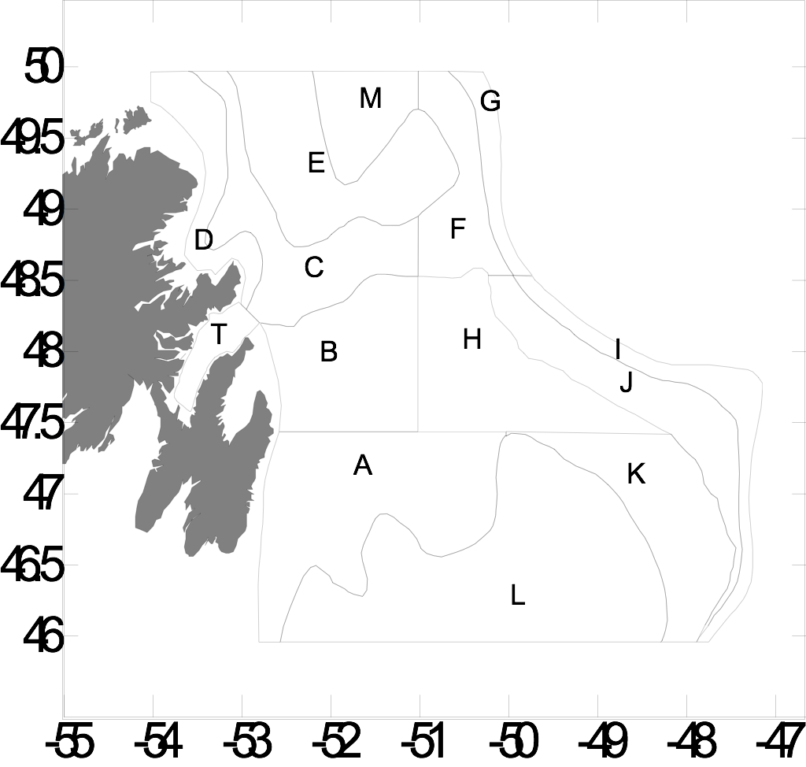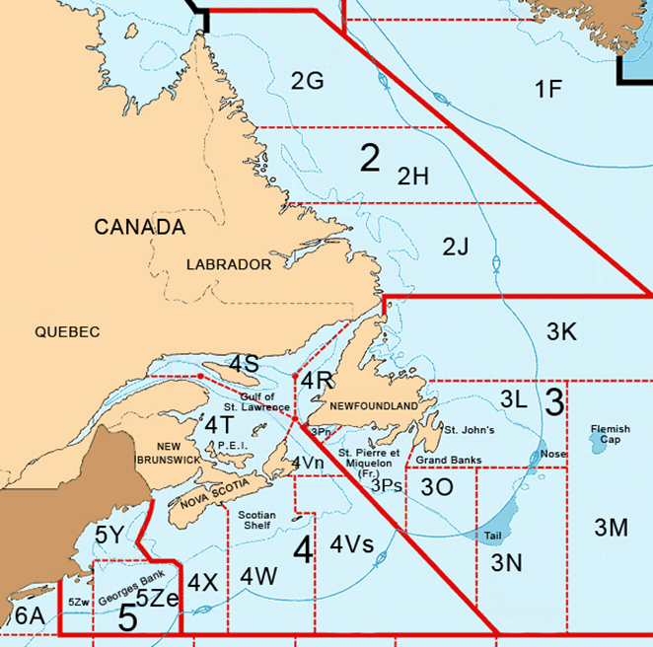

B

A

Fig. 2

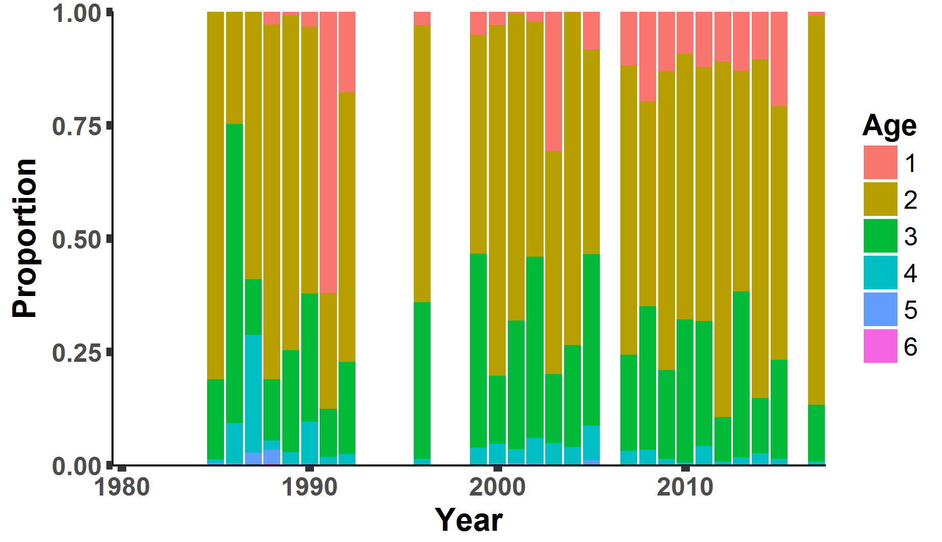

Fig. 3

Year

Fig. 4

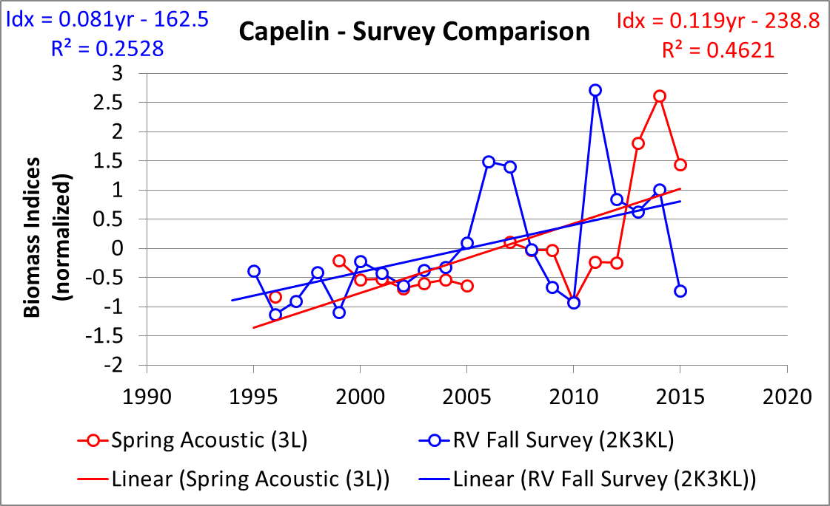

Fig. 5

**Year**

Fig. 6 (need lat and longs)

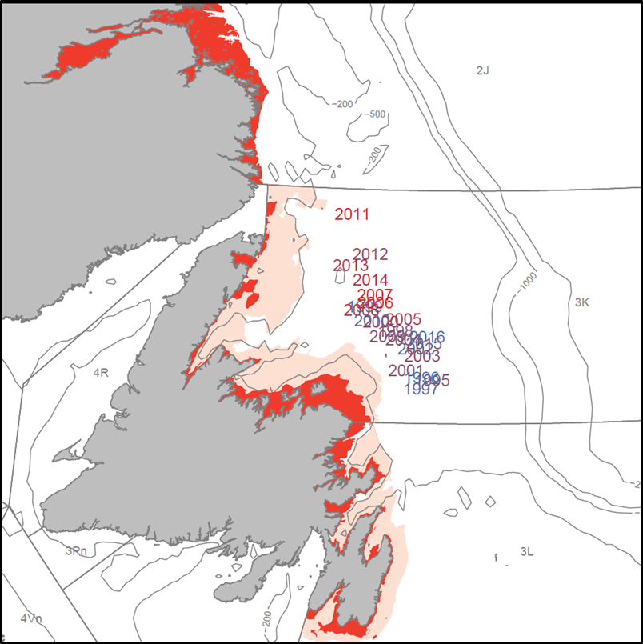

Fig. 7 need a legend for dark + light gray bars

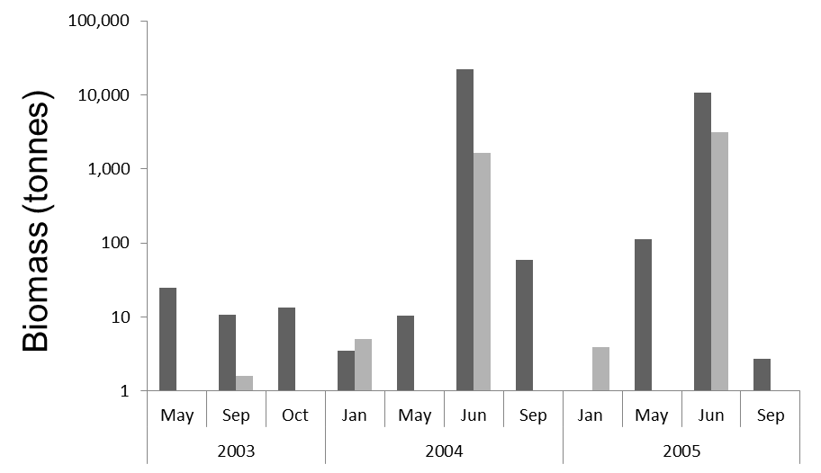

Year

Fig. 8

